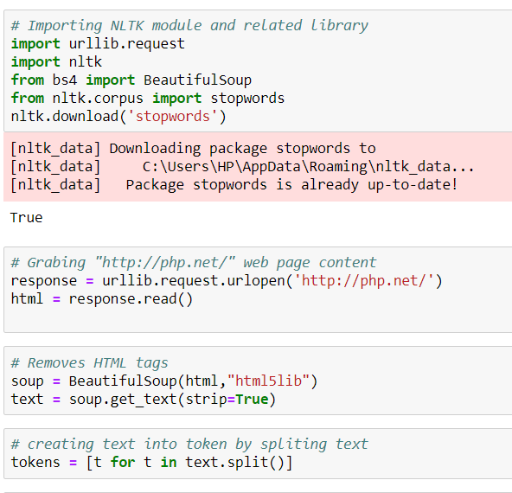

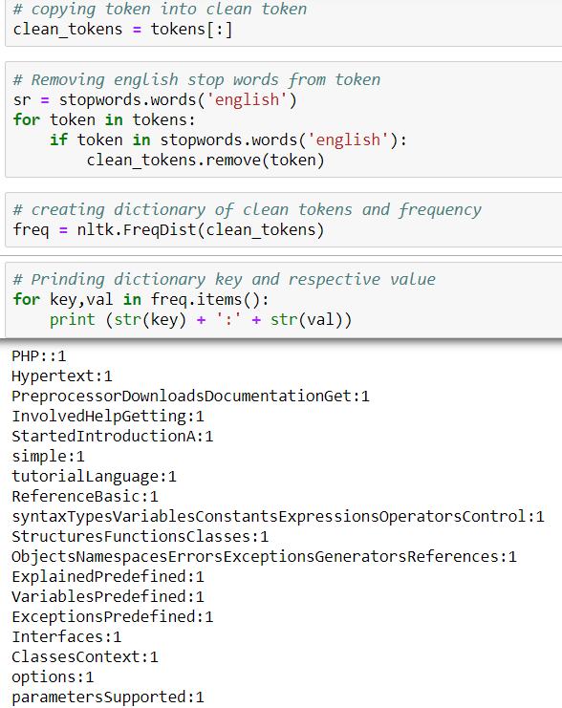

**Output:**

PHP::1

Hypertext:1

PreprocessorDownloadsDocumentationGet:1

InvolvedHelpGetting:1

StartedIntroductionA:1

simple:1

tutorialLanguage:1

ReferenceBasic:1

syntaxTypesVariablesConstantsExpressionsOperatorsControl:1

StructuresFunctionsClasses:1

ObjectsNamespacesErrorsExceptionsGeneratorsReferences:1

ExplainedPredefined:1

VariablesPredefined:1

ExceptionsPredefined:1

Interfaces:1

ClassesContext:1

options:1

parametersSupported:1

Protocols:1

WrappersSecurityIntroductionGeneral:1

considerationsInstalled:1

CGI:1

binaryInstalled:1

Apache:1

moduleSession:1

SecurityFilesystem:1

SecurityDatabase:1

SecurityError:1

ReportingUsing:1

Register:1

GlobalsUser:1

Submitted:1

DataMagic:1

QuotesHiding:1

PHPKeeping:1

CurrentFeaturesHTTP:1

authentication:1

PHPCookiesSessionsDealing:1

XFormsHandling:1

file:1

uploadsUsing:1

remote:1

filesConnection:1

handlingPersistent:1

Database:1

ConnectionsSafe:1

ModeCommand:1

line:1

usageGarbage:1

CollectionDTrace:1

Dynamic:1

TracingFunction:1

ReferenceAffecting:1

PHP's:1

BehaviourAudio:1

Formats:1

ManipulationAuthentication:1

ServicesCommand:1

Line:1

Specific:2

ExtensionsCompression:1

Archive:1

ExtensionsCredit:1

Card:1

ProcessingCryptography:1

ExtensionsDatabase:1

ExtensionsDate:1

Time:1

Related:4

ExtensionsFile:1

System:1

ExtensionsHuman:1

Language:1

Character:1

Encoding:1

SupportImage:1

Processing:1

GenerationMail:1

ExtensionsMathematical:1

ExtensionsNon-Text:1

MIME:1

OutputProcess:1

Control:1

ExtensionsOther:2

Basic:1

ServicesSearch:1

Engine:1

ExtensionsServer:1

ExtensionsSession:1

ExtensionsText:1

ProcessingVariable:1

Type:1

ExtensionsWeb:1

ServicesWindows:1

Only:1

ExtensionsXML:1

ManipulationGUI:1

ExtensionsKeyboard:1

Shortcuts?This:1

helpjNext:1

menu:2

itemkPrevious:1

itemg:1

pPrevious:1

man:2

pageg:1

nNext:1

pageGScroll:1

bottomg:1

gScroll:1

topg:1

hGoto:1

homepageg:1

sGoto:1

search(current:1

page)/Focus:1

search:1

boxPHP:1

popular:2

general-purpose:1

scripting:1

language:1

especially:1

suited:1

web:1

development.Fast,:1

flexible:1

pragmatic,:1

PHP:132

powers:1

everything:1

blog:1

websites:1

world.Download7.1.29·Release:1

Notes·Upgrading7.2.18·Release:1

Notes·Upgrading7.3.5·Release:1

Notes·Upgrading03:1

May:3

2019PHP:6

7.1.29:2

ReleasedThe:21

development:12

team:25

announces:12

immediate:12

availability:12

7.1.29.:1

This:13

security:6

release.All:2

7.1:2

users:12

encouraged:12

upgrade:7

version.For:8

source:32

downloads:25

please:25

visit:25

ourdownloads:7

page,:7

Windows:24

binaries:24

found:68

onwindows.php.net/download/.:7

The:20

list:30

changes:15

recorded:7

theChangeLog.02:2

7.2.18:2

7.2.18.:1

release:74

also:27

contains:5

several:5

minor:2

bug:5

fixes.All:4

7.2:3

7.3.5:2

Release:17

AnnouncementThe:3

7.3.5.:1

7.3:15

theChangeLog.04:3

Apr:3

7.1.28:2

7.1.28.:1

7.2.17:2

7.2.17.:1

7.3.4:2

7.3.4.:1

theChangeLog.22:1

Nov:2

2018PHP:14

7.3.0RC6:2

glad:13

announce:13

presumably:1

last:1

7.3.0:23

pre-release,:6

7.3.0RC6.:1

rough:13

outline:13

cycle:12

specified:13

thePHP:13

Wiki.For:13

thedownload:13

page.:12

sources:17

onwindows.php.net/qa/.Please:12

carefully:13

test:19

version:19

report:18

issues:13

thebug:18

reporting:13

system.THIS:17

IS:17

A:17

DEVELOPMENT:17

PREVIEW:17

-:17

DO:18

NOT:18

USE:17

IT:17

IN:17

PRODUCTION!For:17

information:18

new:18

features:18

changes,:18

read:23

theNEWSfile,:18

theUPGRADINGfile:18

complete:18

upgrading:18

notes.:18

Internal:8

listed:8

theUPGRADING.INTERNALSfile.:8

These:18

files:18

archive.The:13

next:20

would:13

(GA),:1

planned:18

December:1

6th.The:1

signatures:13

inthe:13

manifestor:13

onthe:13

QA:13

site.Thank:13

helping:18

us:18

make:18

better.08:1

7.3.0RC5:2

7.3.0RC5.:1

RC6,:1

November:2

22nd.The:1

better.25:1

Oct:3

7.3.0RC4:2

7.3.0RC4.:1

RC5,:1

8th.The:1

better.11:1

7.3.0RC3:2

7.3.0RC3.:1

RC4,:1

October:2

25th.The:1

better.28:2

Sep:3

7.3.0RC2:2

7.3.0RC2.:1

RC3,:1

11th.The:1

better.13:1

7.3.0RC1:2

7.3.0RC1.:1

RC2,:1

September:2

27th.The:1

better.30:1

Aug:5

7.3.0.beta3:1

seventh:1

version,:7

7.3.0beta3.:1

7.3.0beta3:1

RC1,:1

13th.The:1

better.16:1

7.3.0.beta2:1

sixth:1

7.3.0beta2.:1

7.3.0beta2:1

Beta:7

3,:2

August:3

30th.The:1

better.02:1

7.3.0.beta1:1

fifth:1

7.3.0beta1.:1

7.3.0beta1:1

2,:2

16th.The:1

better.19:1

Jul:3

7.3.0alpha4:2

fourth:2

7.3.0alpha4.:1

1,:2

2nd.The:1

better.05:1

alpha:3

3:8

third:3

Alpha:12

3.:3

July:2

19th.The:1

better.21:1

Jun:2

2:2

second:2

2.:2

5.The:1

better.07:1

1:4

ReleasedPHP:1

first:4

1.:2

starts:1

cycle,:1

page.Please:1

system.Please:1

use:1

production,:1

early:1

June:1

21.The:1

better.01:1

Feb:1

7.2.2:2

7.2.2.:1

bugfix:1

release,:1

fixes:2

included.All:1

theChangeLog.12:1

2017PHP:5

7.2.0:15

Candidate:14

4:2

RC4.:1

7.2.0.:4

All:5

carefully,:5

bugs:5

incompatibilities:5

tracking:5

archive.For:5

thedownloadpage,:5

atwindows.php.net/qa/.The:4

announced:2

26th:1

October.:2

You:5

full:5

releases:5

onour:4

wiki.Thank:4

RC3.:1

12th:1

better.31:1

released:3

14th:1

September.:1

better.17:1

final:1

beta:2

31th:1

August.:1

better.06:1

improvements:1

relative:1

onwindows.php.net/qa/.The:1

20th:1

July.:1

ourwiki.Thank:1

better.Older:1

News:1

EntriesConferences:1

calling:1

papersphp[world]:1

2019Upcoming:1

conferencesCoderCruise:1

2019PHPConf.Asia:1

2019SymfonyCon:1

Amsterdam:1

2019SymfonyLive:1

Berlin:1

2019User:1

Group:1

EventsSpecial:1

ThanksSocial:1

media@official_phpCopyright:1

©:1

2001-2019:1

GroupMy:1

PHP.netContactOther:1

PHP.net:1

sitesPrivacy:1

policy:1